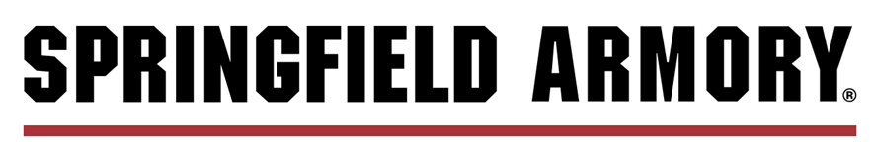
JOB POSTING
Direct Link: Accounting Application

Title: General Accountant
Status: Full-Time

Description Summary:

Springfield Inc. is currently seeking detail-oriented and organized applicants for General Accountant. The ideal candidate will have a broad understanding of corporate accounting and will be responsible for coordinating day-to-day accounts receivable operations, preparing management reporting, maintaining accurate financial records, and contributing positively to our team culture. In addition, the General Accountant:

- Records, posts, verifies customer payments and transactions related to accounts receivable.
- Creates customer invoices.
- Assists in regular financial closing responsibilities.
- Contributes to ad-hoc requests and projects, assigned by management, auditors, regulatory bodies, etc.
- Completes general ledger and customer account reconciliations to detect errors or discrepancies.
- Prepares journal entries, as needed, to record financial impacts of company activity and/or to adjust previously recorded activity to provide accurate financial records.
- Provides additional support, as needed, for inventory, payroll, general ledger and accounts payable activities.

Successful applicants will possess an eye toward process improvement, a positive attitude, and the confidence to speak up, make suggestions and ask questions when necessary.

Requirements:

Bachelor’s degree (relevant field) and work experience/internship is required. Recent graduates are welcome to apply. Qualified applicants will possess exceptional organizational and communication skills. The ability to form cooperative work relationships is expected. High level of proficiency in the operation of Microsoft programs (Excel) is essential. Attention to detail and accuracy is critical to ensure error-free records for financial reporting. This position is trusted to handle and protect company-private information: discretion, integrity, and ethics nonnegotiable.

Compensation:

Springfield offers a competitive salary and extensive benefits package which includes a generous, comprehensive, and affordable health plan in addition to dental, vision, life, disability, flex, 401(k), and other options. To learn more about Springfield Armory products and services visit www.springfield-armory.com. ($60,000- $80,000)

Submit Resume and/or Contact Information for Consideration
Follow link to complete inquiry form. Attach resume and provide accurate contact information.

Direct Link: Accounting Application

Springfield Inc. is an Equal Opportunity Employer

Approved for Posting: AK
Posting Closes: When Positions is Filled.

